UNIT III
Context Free Grammar, Derivation trees, Simplification of Context Free Grammar, Chomsky Normal Form, Pushdown automata and their equivalence.

DEFINITION OF A GRAMMAR:- A grammar G has four tuples (V_{N}, Ʃ, P, S), where

(i) V_{N} is a finite nonempty set, whose elements are called variables,

(ii) Ʃ is a finite nonempty set, whose elements are called terminals,

(iii) V_{N} Ո Ʃ = ϕ.

(iv) S is a special variable (i.e, an element of V_{N}) called the start symbol, and

(v) P is a finite set whose elements are αβ. Where α and β are strings on V_{N} U Ʃ. α has at least one symbol from V_{N}. The elements of P are called productions or production rules or rewriting rules.

Example:- S aA, AB, SAB, B a, BABS.

If A α is a production where A ϵ V_{N}, then it is called an A- production.

If A α₁, A α₂, …., A α_{m}, are A- production. These productions can be written as Aα₁ | α₂ | …..| α_{m} .
(a) Reverse substitution is not permitted. For example, if SAB is a production, then we can replace S by AB. but we cannot replace AB by S.
(b) No inversion operation is permitted. For example, if SAB is a production. It is not necessary that ABS is a production.

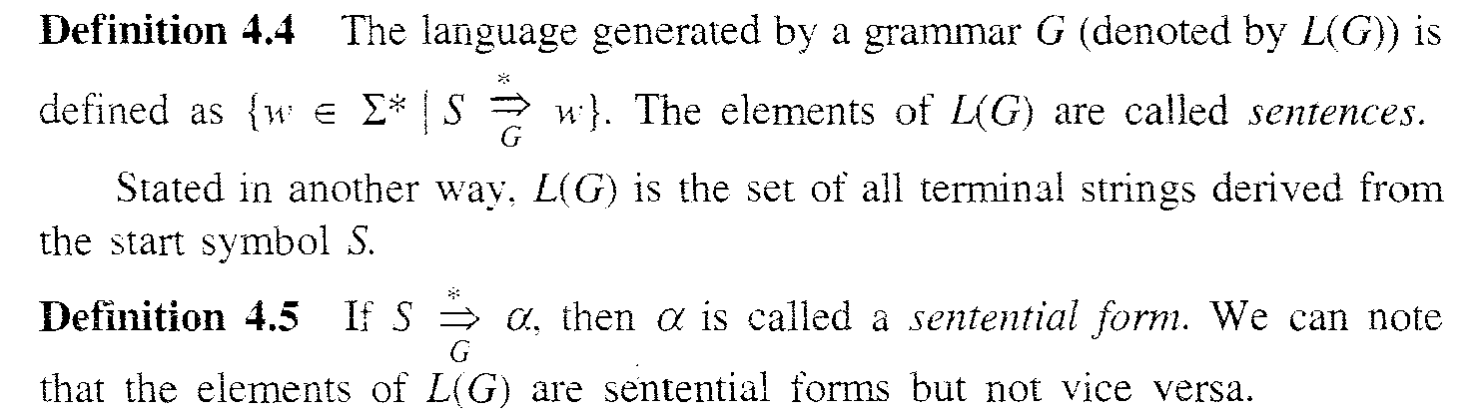

DERIVATIONS AND THE LANGUAGE GENERATED BY A GRAMMAR

Productions are used to derive one string over V_{N} U Ʃ from another string.

Example 1:- G = ({S}, {a}, { SaS | a}, S)
SaSaaSaaaSaaaa…..a.
So we can write L(G) = {a}⁺

Example 2 :- G = ({S}, {a,b}, { SaS | bS | Ʌ}, S)
SaSabSabaSabaaSabaab.
So we can write L(G) = {a , b}*

Example 3:- G = ({S}, {0, 1}, { S0S1| 01}, S)
S 0S1 00S11 000S111 000…S111… 0000…n time 1111…n times.
So we can write L(G) = {0^{n}1^{n} | n > 0 }

Example 4:- G = ({S}, {0, 1}, { S0S1 | Ʌ }, S)
Solution:- ??

Example 5:-
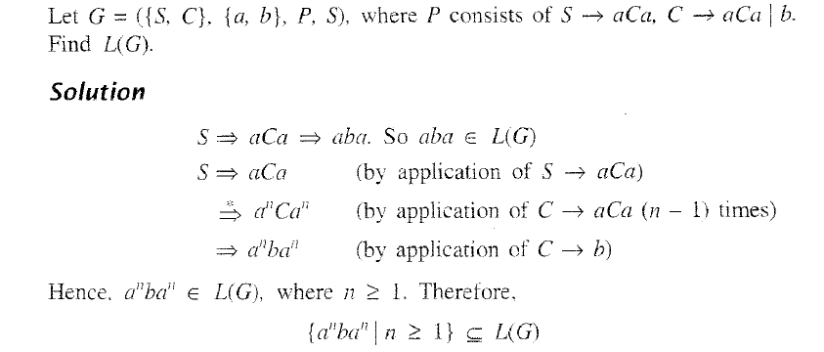

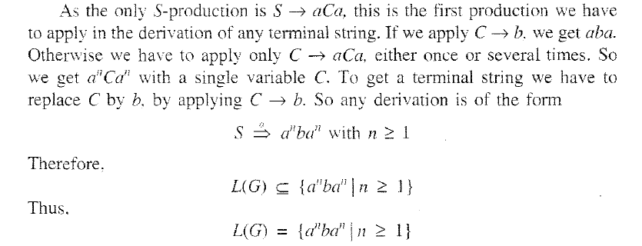

Example 6:- Construct a grammar G so that L(G) = {a^{n}b^{n}c^{i} | n ≥ 1, i ≥ 0}.

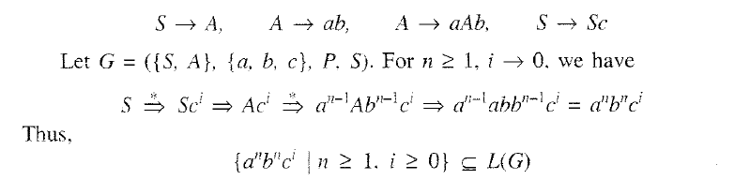

Q1:- Construct a grammar G so that L(G) = {a^{j}b^{n}c^{n} | n ≥ 1, j ≥ 0}.

Q2:- Construct a grammar G so that L(G) = {a^{n}ba^{m} | n, m ≥ 1}.

CHOMSKY CLASSIFICATION OF LANGUAGES
Chomsky classified the grammars into four types in terms of productions (types 0-3).
Type 3 known as Regular grammar.
Type 2 known as Context free grammar.
Type 1 known as Context sensitive grammar.
Type 0 known as Unrestricted grammar.

Relation between LANGUAGES and AUTOMATA

Following figure describes the relation between the four types of languages and automata: TM (Turing Machine), LBA (Linear Bound Automaton), PDA (Pushdown Automaton), and FA (Finite Automaton).
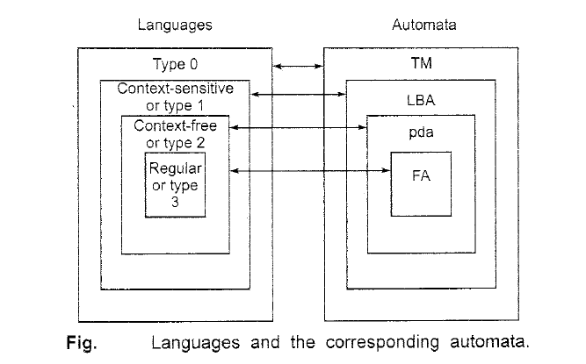

Context Free Grammar (CFG)

Generation of Derivation Tree:-
A derivation tree or parse tree is an ordered rooted tree that graphically represents the semantic information a string derived from a context-free grammar.

Representation Technique
- Root vertex − Must be labeled by the start symbol.
- Vertex − Labeled by a non-terminal symbol.
- Leaves − Labeled by a terminal symbol or Ʌ.
If S → x₁x₂ …… x_{n} is a production rule in a CFG, then the parse tree / derivation tree will be as follows −
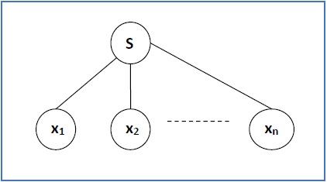
There are two different approaches to draw a derivation tree −
Top-down Approach −
- Starts with the starting symbol S.
- Goes down to tree leaves using productions.
Bottom-up Approach −
- Starts from tree leaves.
- Proceeds upward to the root which is the starting symbol S.

Derivation or Yield of a Tree:-
The derivation or the yield of a parse tree is the final string obtained by concatenating the labels of the leaves of the tree from left to right, ignoring the Nulls. However, if all the leaves are Null, derivation is Null.

Example 1:-

Let a CFG { V_{N}, Ʃ, P, S } be
V_{N} = { S }, Ʃ = { a, b }, Starting symbol = S, P = ( S → SS | aSb | Ʌ )
One derivation from the above CFG is abaabb
S → SS → aSbS → abS → abaSb → abaaSbb → abaabb

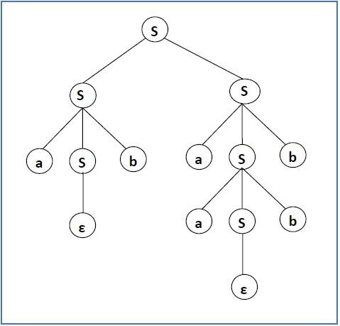

Example 2:-
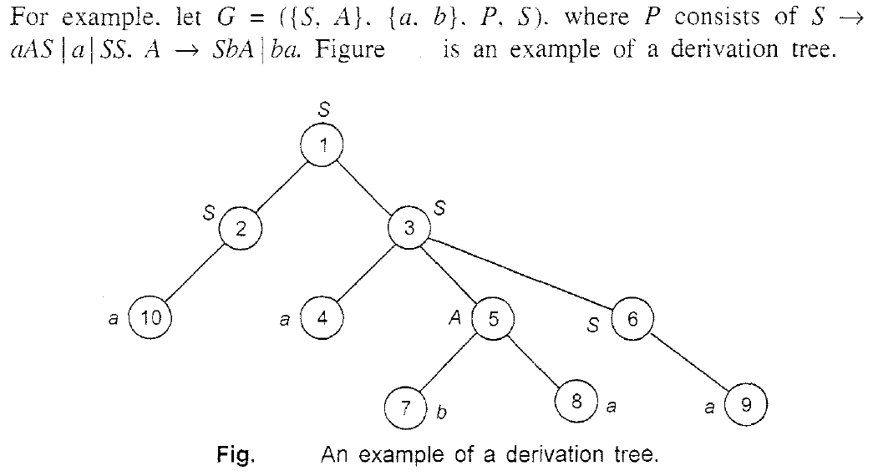
The yield of the derivation tree of above fig. is aabaa.

Sentential Form and Partial Derivation Tree:-
A partial derivation tree is a sub-tree of a derivation tree / parse tree such that either all of its children are in the sub-tree or none of them are in the sub-tree.
Example
If in CFG the productions are −
S → AB, A → aaA | Ʌ, B → Bb| Ʌ
the partial derivation tree can be the following −
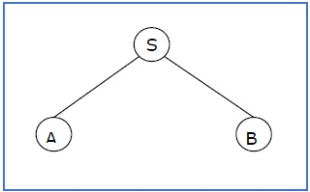

If a partial derivation tree contains the root S, it is called a sentential form. The above sub-tree is also in sentential form.

Leftmost and Rightmost Derivation

- Leftmost derivation :- A leftmost derivation is obtained by applying production to the leftmost variable in each step.

- Rightmost derivation :- A rightmost derivation is obtained by applying production to the rightmost variable in each step.

Ex 1:-Let any set of production rules in a CFG be

X → X+X | X*X | X | a over an alphabet {a}

Leftmost derivation for the string a+a*a may be as follows.

X → X+X → a+X → a + X*X → a+a*X → a+a*a

The stepwise derivation of the above string is shown as below –
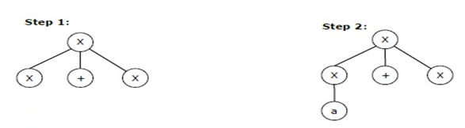
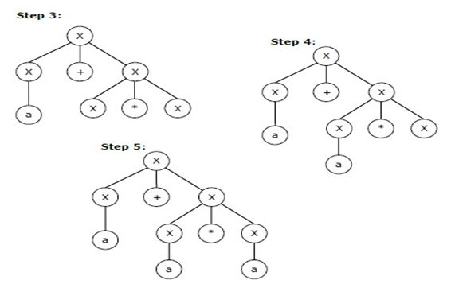

Rightmost derivation for the string a+a*a may be as follows.

X → X + X → X + X * X → X + X * a → X + a * a → a + a * a

The stepwise derivation of the above string is as below:-
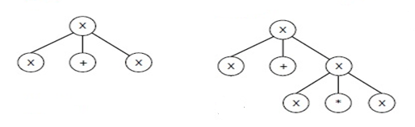
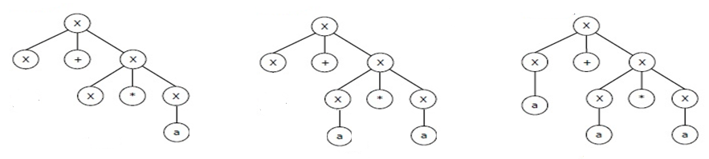
Ex 2:- Let a CFG { V_{N}, Ʃ, P, S } be
V_{N} = {S}, Ʃ = {a, b}, Starting symbol = S, P = S → SS | aSb | ε
The leftmost derivation for the string abaabb is as follows.
S → SS → aSbS → abS → abaSb → abaaSbb → abaabb



The Rightmost derivation for the string abaabb is as follows.
S → SSSaSbSaaSbbSaabbaSbaabbabaabb

Ex 3:- Let a CFG { V_{N}, Ʃ, P, S }, where
V_{N} = {S, A}, Ʃ = {a, b}, ( P consists of S → SS | aAS | a, A → SbA | ba )
The Leftmost derivation for the string aabaa may be –
S SS aS aaAS aabaS aabaa

Derivation tree is as follows.
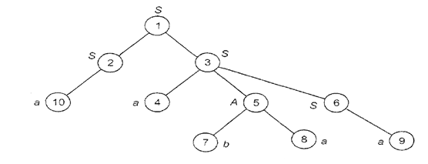
The rightmost derivation for the string aabaa may be –
S SS SaAS SaAa Sabaa aabaa

Ambiguity :- If a CFG generates the same string in several different ways, we say that the string is derived ambiguously in that grammar. If a CFG generates some string we say that the grammar is ambiguous.
Example 1:- The grammar G, whose productions are E → E+E | E*E | E | a has ambiguous expressions. Here two different trees for a+a*a are possible.
Leftmost Derivation(s)

EE*E E+E*Ea+E*Ea+a*E a+a*a

EE+E a+Ea+E*E a+a*E a+a*a
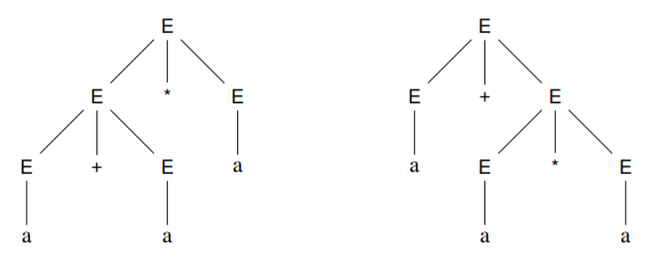
- When a grammar generates a string ambiguously it means that the string has two different derivation trees.
- However, two different derivations may produce the same derivation tree because they may differ in the order in which they replace non-terminals, not in the rules they use. To concentrate on the structure of the derivations we need to fix the order of rule application (either follow leftmost or rightmost).

Example 2:- If G is the grammar S → SbS | a, show that G is ambiguous.

Sol:- To prove that G is ambiguous, we have to find w Є L(G), which is ambiguous. Consider w = abababa ϵ L(G). Then we get two derivation trees for w and hence show that G is ambiguous.

Two derivation tree for string w= abababa are as follows.

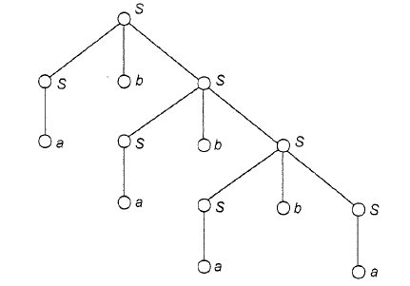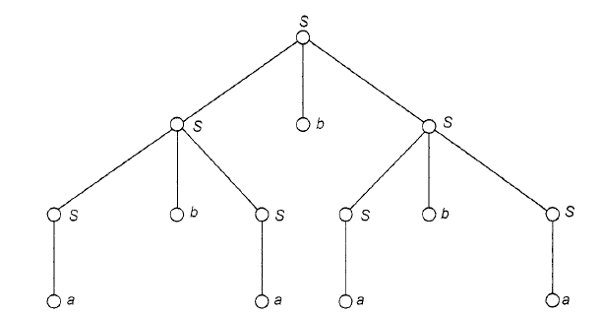

Q1:- If G is the grammar S → SS | (S) | Ʌ, show that G is ambiguous.

Also draw derivation tree(s) for it.

SIMPLIFICATION OF CONTEXT-FREE GRAMMARS

Eliminate those symbols and productions in G which are not useful for the derivation of sentences.

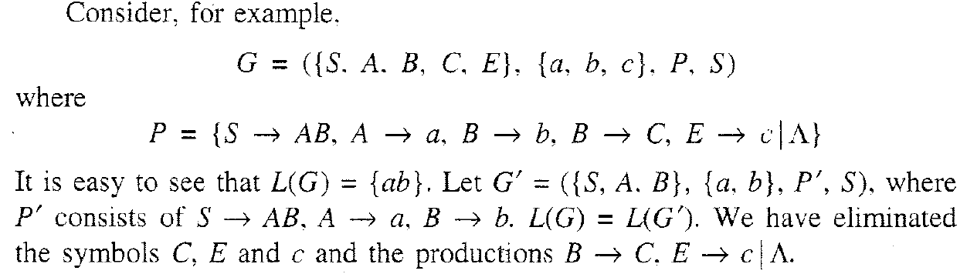

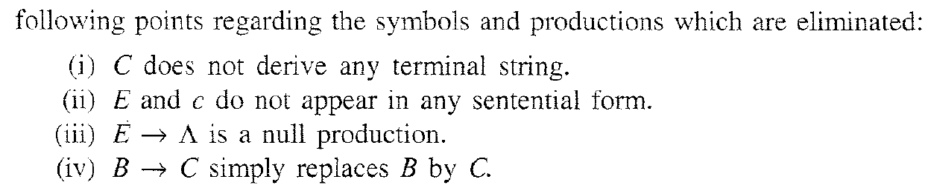

CONSTRUCTION OF REDUCED GRAMMARS:-
Theorem 1:- If G is a CFG such that L(G) ≠ Փ, we can find an equivalent grammar G' such that each variable in G' derives some terminal string.

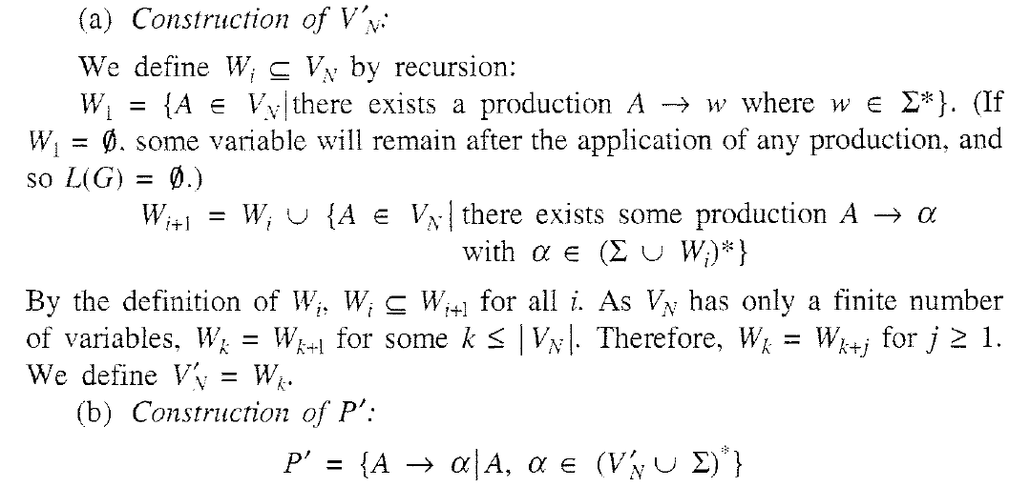
By applying (a) and (b), equivalent grammar G’ = (V’_{N}, Ʃ, P’, S)
Example 1:- Reduce the grammar G = (V_{N}, Ʃ, P, S),
where P = ( S → AB, A → a, B → b, B → C, E → c)
Sol:-
(a) Construction of V’_{N}:
W₁ = { A, B, E }, since A → a, B → b, E → c

#Any combination of (A, B, E, a, b, c) as a right side of variables will be part of W₂.
W₂ = W₁ U { S } = { A, B, E, S } since A → a, B → b, E → c, SAB
#Any combination of (A, B, E, S, a, b, c) as a right side of variables will be part of W₃.
W₃ = W₂ U ϕ = W₂ = { A, B, E, S } # Generate W_{i} until W_{i} = W_{i+1}

Therefore , V’_{N} = { S, A, B, E }
(b) Construction of P’: { S → AB, A → a, B → b, E → c }
Finally G’ = ({ S, A, B, E }, { a, b, c }, P’, S )

Theorem 2:-
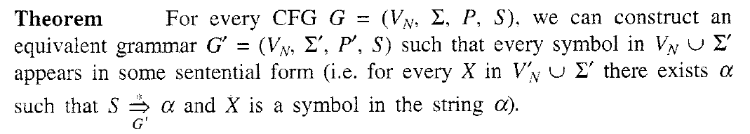
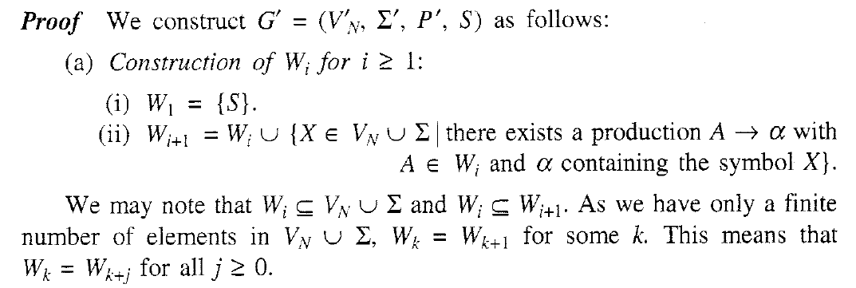
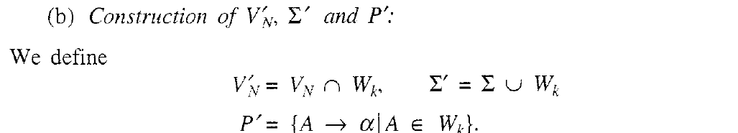
Example 1:- Let G = ({ S, A, B, E), {a, b, c}, P, S), where
P consists of S → AB, A → a, B → b, E → c
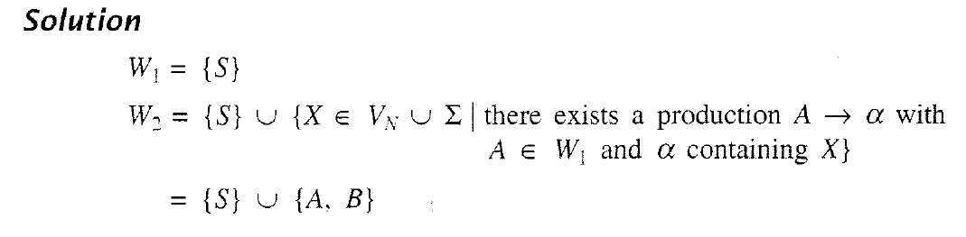
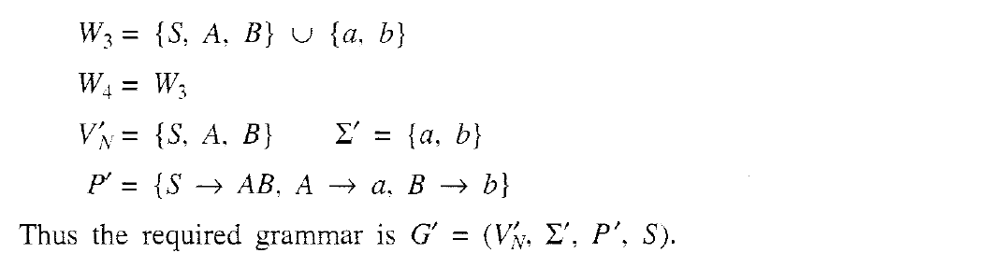
Steps to construct the reduced grammar in two steps.

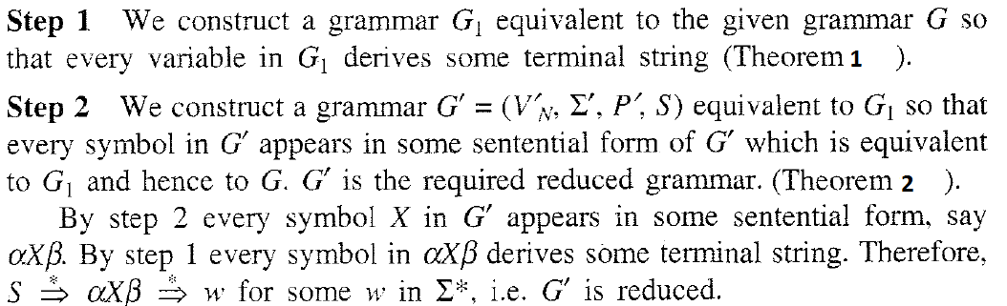

Note: To get a reduced grammar, we must first apply Theorem 1 and then Theorem 2. If we apply Theorem 2 first and then Theorem 1, we may not get a reduced grammar.

Ex 1. Find a reduced grammar equivalent to the grammar G whose productions are

S → AB | CA, A → a, B → BC | AB, C → ab | b
Sol:- Apply Theorem 1:-
W₁ = { A, C }, since A → a, C → ab | b

# Any combination of (A, C, a, b) will be part of W₂.
W₂ = { A, C, S }, since A → a, C → ab | b, S → CA

#Any combination of (A, C, S, a, b) will be part of W₃.
W₃ = W₂ U ϕ = W₂ = { A, C, S }, since A → a, C → ab | b, S → CA

Apply Theorem 2:-
G’ = ( V’_{N} = { S, A, C }, Ʃ’ = { a, b }, P’ = (A → a, C → ab | b, S → CA), S )

W₁ = { S }

W₂ = { S } U { C, A }

W₃ = { S, C, A } U { a, b }

W₄ = W₃

Reduced G’’= (V’’_{N} = { S, A, C }, Ʃ’’ = { a, b }, P’’ = (A→ a, C → ab | b, S → CA), S )

Ex 2. Construct a reduced grammar equivalent to the grammar
S → aAa, A → Sb | bCC | DaA, C → abb | DD, D → aDa, E → aC

Sol:- Apply theorem 1:-

W₁= { C }, since C → abb

W₂= { C, A, E }, since C → abb, A → bCC, E → aC

W₃= { C, A, E, S }, since C → abb, A → bCC, E → aC, S → aAa

W₄= { C, A, E, S }, since C → abb, A → bCC, E → aC, S → aAa, A → Sb

P’ = (C → abb, A → bCC, E → aC, S → aAa, A → Sb)

V’_{N} = { C, A, E, S },

Apply theorem 2:-

W₁ = { S }

W₂ = { S, A}, S → aAa

W₃ = { S, A, C}, S → aAa, C → abb, A → bCC | Sb

W₄ = { S, A, C}, S → aAa, C → abb, A → bCC | Sb

G’’ = (V’’_{N} = { C, A, S }, {a,b}, P’’ = (C → abb, A → bCC, S → aAa, A → Sb), S )

Ex 3. Find a reduced grammar equivalent to the grammar

S aAa, AbBB, Bab, CaB

Sol:- ???

ELIMINATION OF NULL PRODUCTIONS

Definition:- A variable A in an CFG is nullable if A * > Ʌ.
**
Steps:-
- Find non-terminals that derive Ʌ .
- For each production A → w, construct new productions A → w’ where w’ is obtained from w, by removing one or more productions of the non-terminals from Step 1.
- Combine the original productions with those of step 2 and eliminate any Ʌ -productions.
Example 1:- Remove Ʌ - productions from the grammar.
S → ABc
A → aA | Ʌ
B → bB | Ʌ
Sol.
Step 1: The non-terminals A and B derive Ʌ .
Step 2: From production S → ABc, we construct new productions as S → Bc | Ac | c.
From production A → aA, we construct new production as A → a.
From the production B → bB we construct new production as B → b.
Step 3: S → ABc | Bc | Ac | c
A → aA | a
B → bB | b.

Example 2:- Remove Ʌ - productions from the grammar.
S → ABc | Ab | c
A → aA | Ʌ
B → bB | Ʌ
Sol:- S → ABc | Bc | Ac | c | Ab | b
A → aA | a
B → bB | b.

ELIMINATION OF UNIT / chain PRODUCTIONS
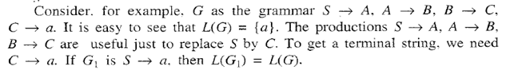
Q. Eliminate chain production
S aS |AB | A | B | a
D →b
AQ
Qc
Therefore SAQc
Elimination of chain production will give new productions as ( Sc, Ac )
After elimination of unit production we write S aS |AB | c | B | a
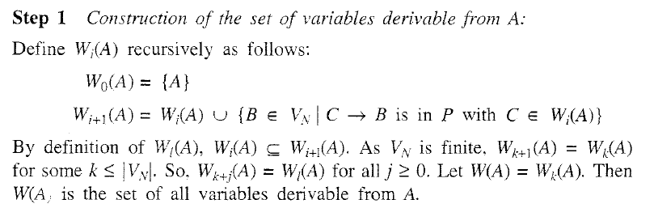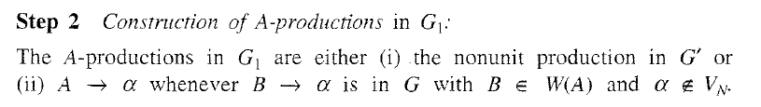
Example 1:- Let G be S AB, A a, B C | b, C D, D E, E a. Eliminate unit productions and get an equivalent grammar.
Sol:-

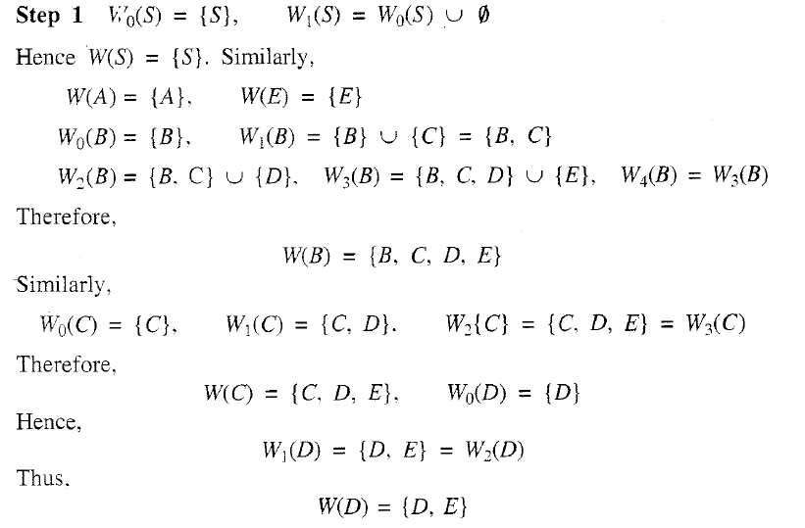
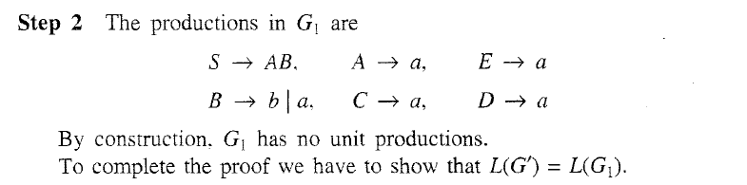

NORMAL FORMS FOR CONTEXT-FREE GRAMMARS:-
In a context-free grammar, the R.H.S. of a production can be any string of variables and terminals. When the productions in G satisfy certain restrictions, then G is said to be in a 'normal form'. Like Chomsky normal form (CNF) and the Greibach normal form (GNF).
CHOMSKY NORMAL FORM:- A context-free grammar G is in CNF, if every production is of the form Xa, or XBC, and S Ʌ is in G if Ʌ ϵ L(G).
Example :- S AB | Ʌ, Aa, Bb

For a grammar in CNF, the derivation tree has the following property:
- Every node has atmost two descendants-either two internal vertices or a single leaf.

Reduction to Chomsky Normal Form:-

Step 1:- Elimination of null productions and unit productions.

Step 2:- Elimination of terminals on R.H.S.:-

For each production whose right hand side has two or more symbols, replace each terminal a with a new nonterminal C_{a} and add the new production C_{a} → a.

Example:-A abBC, then add new productions as C_{a} a, C_{b} b (to replace terminals a and b respectively) and rewrite
AabBC as A C_{a}C_{b}BC #right hand side must have only non-terminals.

Step 3:- Restricting the number of variables on R.H.S.:-
Replace each production B → C₁…C_{n} (if n > 2), with B → C₁D where D → C₂ …C_{n}. Repeat this step until all right sides have length two.

Example:- AWXYZ, then rewrite AWXYZ as AWQ, where Q XYZ.
Again Q XYZ is rewritten as Q XR, where R YZ.

Finally AWXYZ is replaced with new productions as AWQ, Q XR, R YZ
(Keep on adding new variables until all production’s R.H.S. have length 2 only.)

Example 1:- Reduce the following grammar to CNF:

S ASA | bA, A B | S, B c
Sol:-
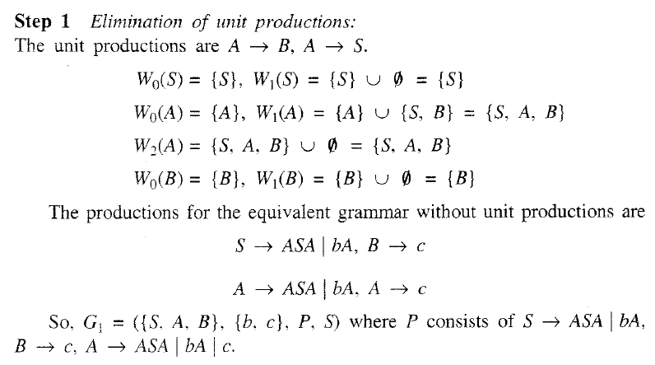
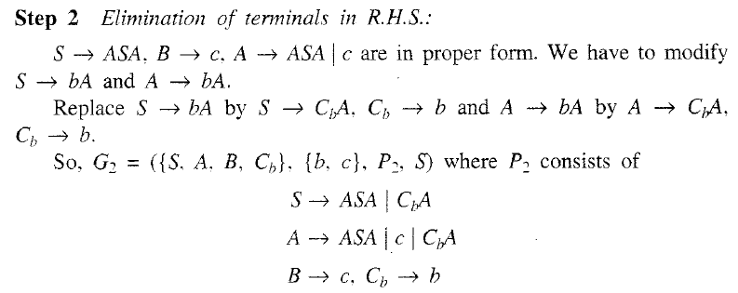
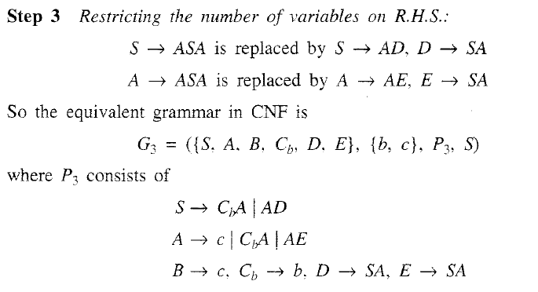
Example 2:- Reduce the following grammar G to CNF.
G is S aAD, A aB | bAB, B b, D d.
Sol:-
Step 1:- As there are no null productions or unit productions, we can proceed to step 2.

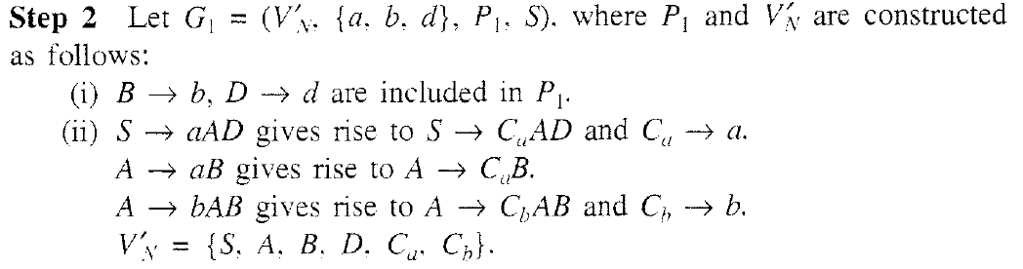
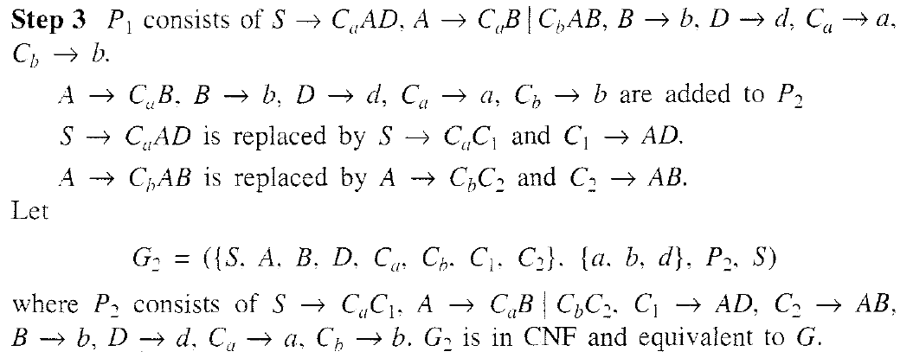

Q1. Construct a Chomsky normal form for the grammar.
S → aSb | D
D → Dc | Ʌ
Sol:-
Step 1:- As there are null productions and unit productions, so we eliminate these.
- S → aSb | ab | D, D → Dc | c #elimination of null productions
- S → aSb | ab | Dc | c, D → Dc | c #elimination of chain productions

Step 2 :- Elimination of terminals in R.H.S.

Step 3:- Restricting the number of variables on R.H.S.

Q1. Consider a CFG G with the following productions.
S ASA | B
A a | b
B aCb | bCa
C ACA | A
And answer the following questions:

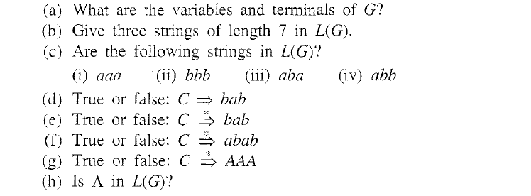

Q2. A derivation tree of a sentential form of a grammar G is given here.
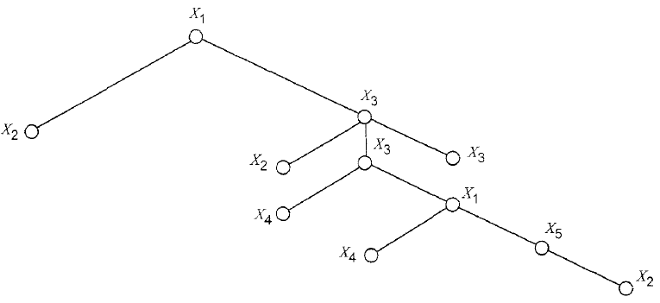
(a) What symbols are necessarily in V_{N}?

(b) What symbols are likely to be in Ʃ ?

(c) Determine if the following strings are sentential forms: (i) X₄X₂ (ii) X₂X₂X₃X₂X₃X₃ (iii) X₂X₄X₄X₂.

